**Question 1**

<!DOCTYPE html>

<html lang="en">

<head>

<meta charset="UTF-8">

<meta name="viewport" content="width=device-width, initial-scale=1.0">

<title>Simple Web Page</title>

<style>

body {

font-family: Arial, sans-serif;

margin: 20px;

text-align: center;

}

h1 {

color: #333;

}

p {

color: #666;

}

</style>

</head>

<body>

<h1>Welcome to Web Technology</h1>

<p>A computer science portal for B. Tech.</p>

</body>

</html>

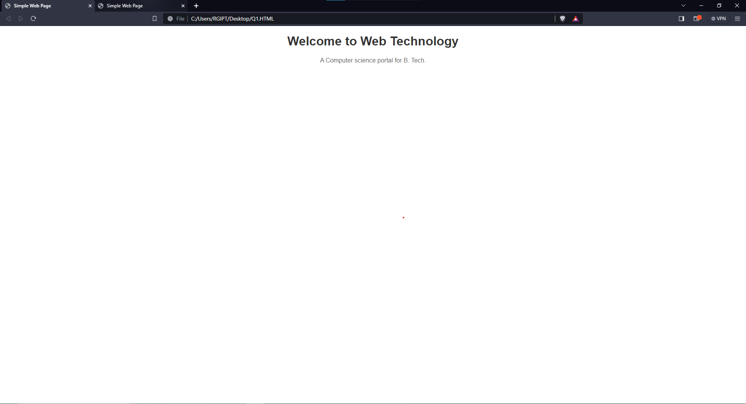

**QUESTION 2**

<!DOCTYPE html>

<html lang="en">

<head>

<meta charset="UTF-8">

<meta name="viewport" content="width=device-width, initial-scale=1.0">

<title>Simple Web Page</title>

<style>

body {

font-family: Arial, sans-serif;

margin: 20px;

text-align: center;

}

h1 {

color: #333;

}

p {

color: #666;

}

</style>

</head>

<body>

<h1>Welcome to Web Technology</h1>

<h2>Welcome to Web Technology</h2>

<h3>Welcome to Web Technology</h3>

<h4>Welcome to Web Technology</h4>

<h5>Welcome to Web Technology</h5>

<h6>Welcome to Web Technology</h6>

<h7>Welcome to Web Technology</h7>

<p>A Computer science portal for B. Tech.</p>

</body>

</html>

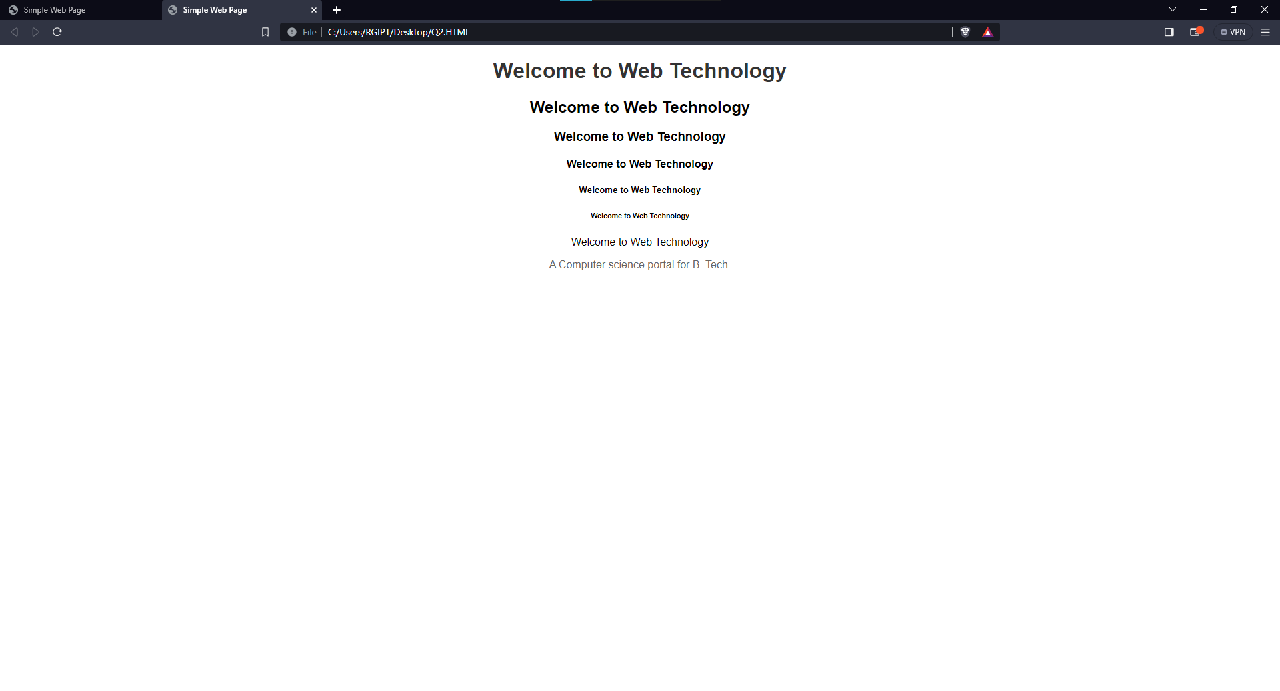

Q3

<!DOCTYPE html>

<html lang = "eng">

<head>

<meta charset = "UTF-8">

<meta name = "viewport" content = "width = device-width,initial scale = 1.0">

<title>

web page

</title>

</head>

<body>

<p>

When it comes to HTML elements, these are the building blocks of this language. Each element is an individual component on a particular web page or document. They are in every part of the page, including the header, footer, body, and text.

</p>

<p>

The format of a tag is a start tag followed by the content and an end tag, eventually. For instance, if you need to use a paragraph element, here is the way to go.

</p>

<p>

In HTML, an element is a section of an HTML document. Some HTML elements represent visible components on a web page, such as text, images, or buttons, while others denote different sections of the page or provide meta-information about the document.

</p>

</body>

</html>

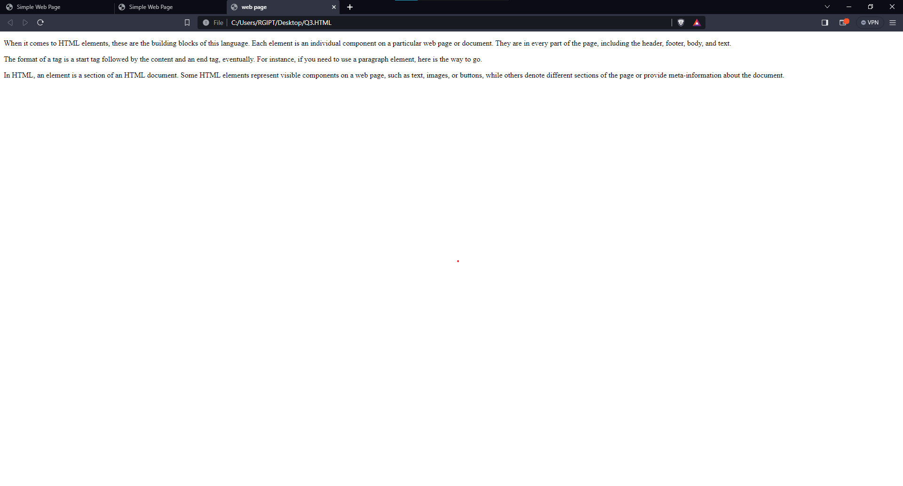

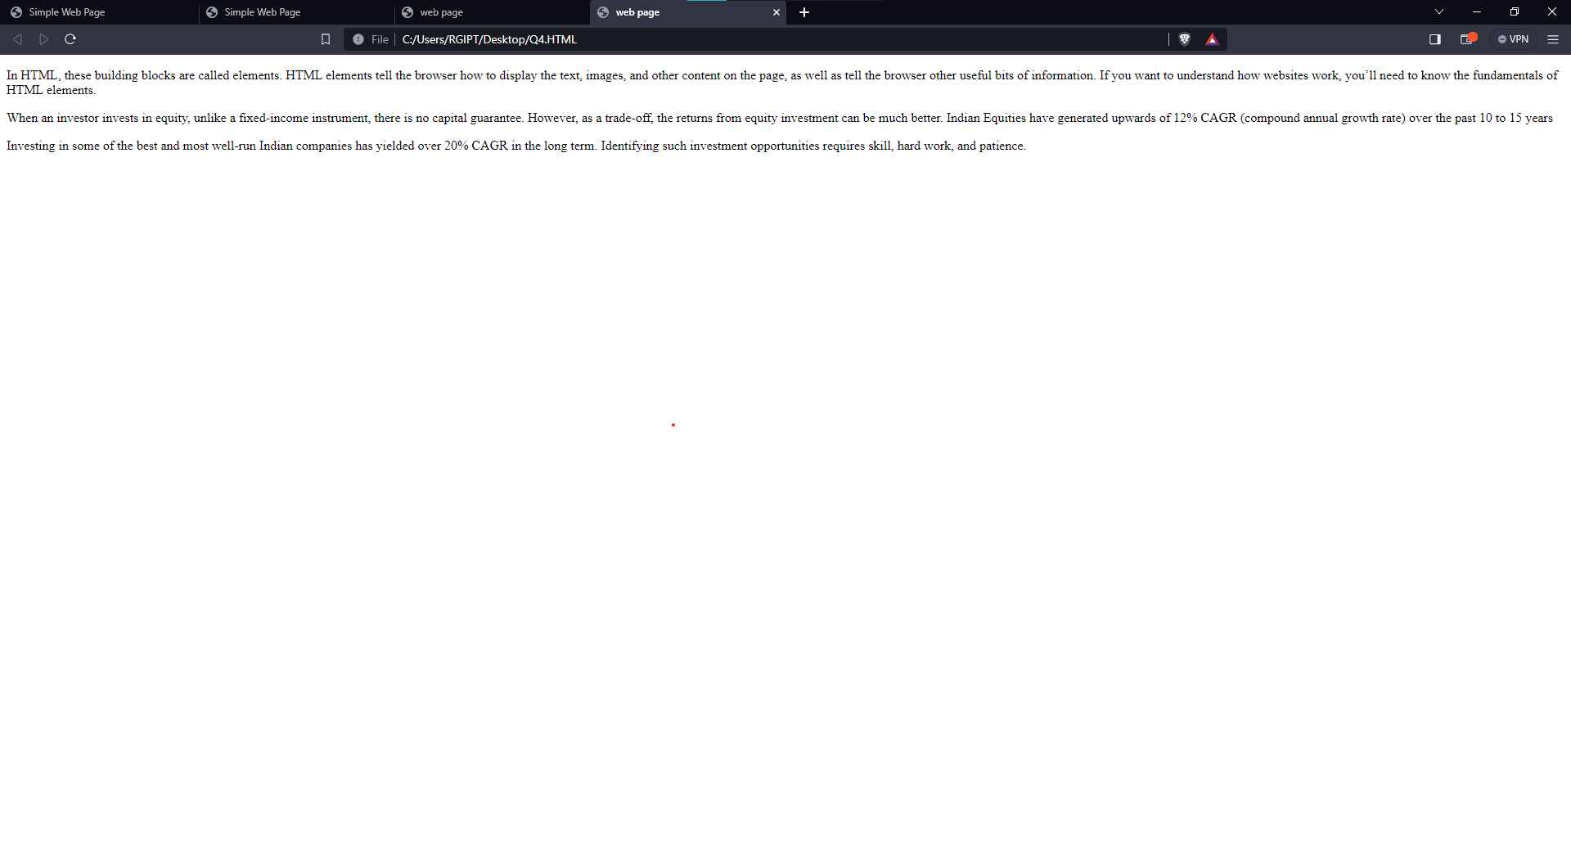\

<!DOCTYPE html>

<html lang = "en">

<head>

<meta charset = "UTF-8">

<meta name = "viewport" content = "width = device-width,initial scale = 1.0">

<title>

web page

</title>

</head>

<body>

<p>

In HTML, these building blocks are called elements. HTML elements tell the browser how to display the text, images, and other content on the page, as well as tell the browser other useful bits of information. If you want to understand how websites work, you’ll need to know the fundamentals of HTML elements.

<p>

When an investor invests in equity, unlike a fixed-income instrument, there is no capital guarantee. However, as a trade-off, the returns from equity investment can be much better. Indian Equities have generated upwards of 12% CAGR (compound annual growth rate) over the past 10 to 15 years

<p>

Investing in some of the best and most well-run Indian companies has yielded over 20% CAGR in the long term. Identifying such investment opportunities requires skill, hard work, and patience.

</p>

</p>

</p>

</body>

</html>

<!DOCTYPE html>

<html lang = "en">

<head>

<meta charset = "UTF-8">

<meta name = "viewport" content = "width = device-width,initial scale = 1.0">

<title>

web page

</title>

</head>

<body>

<header>

<p>

In this blog post, we’ll introduce you to elements in HTML and teach you how to write them correctly. We’ll also provide a list of some of the most common HTML elements that you’ll use in your web pages. Let’s get started..

<h1>

heading

</h1>

</p>

</header>

</body>

</html>

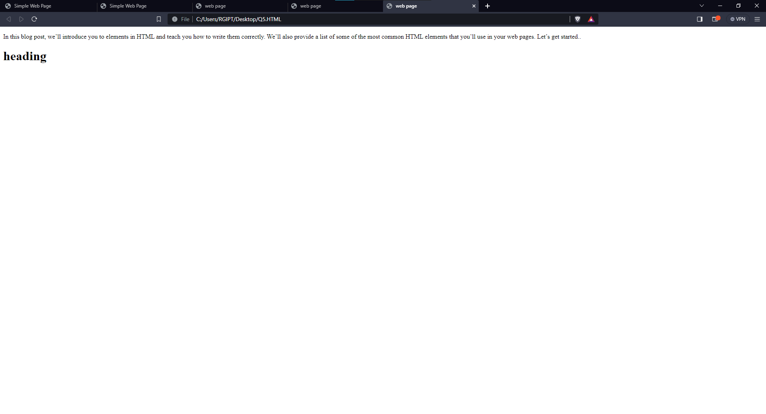

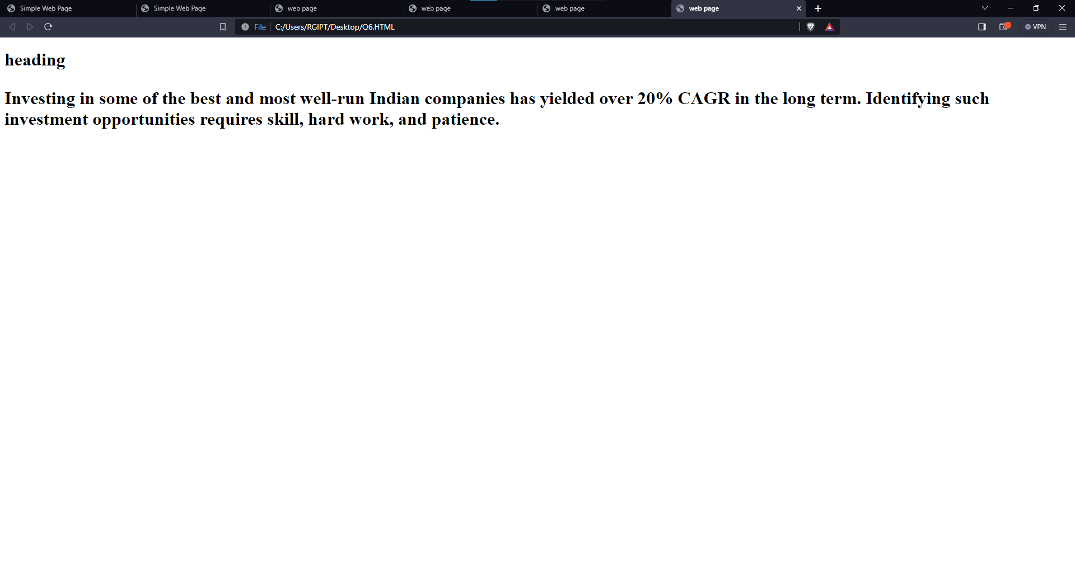

<!DOCTYPE html>

<html lang = "en">

<head>

<meta charset = "UTF-8">

<meta name = "viewport" content = "width = device-width,initial scale = 1.0">

<title>

web page

</title>

</head>

<body>

<header>

<h1>

heading

<p>

Investing in some of the best and most well-run Indian companies has yielded over 20% CAGR in the long term. Identifying such investment opportunities requires skill, hard work, and patience.

</p>

</h1>

</header>

</body>

</html>